Scenario: Forests and Storms
Tornados strike the plains and Midwest area of the United States each year during warmer weather, and sometimes accompany hurricanes in other parts of the country. Through any of these disasters, trees are damaged or destroyed. Some of the most damaging wind loads in North America are due to tornadoes. Tornadoes have windspeeds between 90 and 315 km/h (56 mph to almost 200 mph) and often occur during thunderstorms. Damage path lengths are approximately 10 km on average (although they range considerably between 50 m and 100+ km) or longer. Tornadoes have average damage swaths of approximately 250 m width, but the track cross-sections can vary significantly between 2 m and 2+ km.
Official estimation of peak tornadic wind speeds is performed by the National Weather Service. The F scale is most widely used to classify tornadic wind speed based on the severity of structural damage. In this scheme, observed damage patterns are compared with a series of descriptions and photographic examples of damage to houses, vehicles, trees, and other common objects. There are six categories of damage (F numbers), each corresponding to a range of wind speeds within the interval from 15 to over 130 m/s. Since the F scale relies on damage to structures and property, it is more difficult to use in forested areas.
This model relies on modeling the maximum wind speed at the edge of the tornado, also known as the tangential speed.
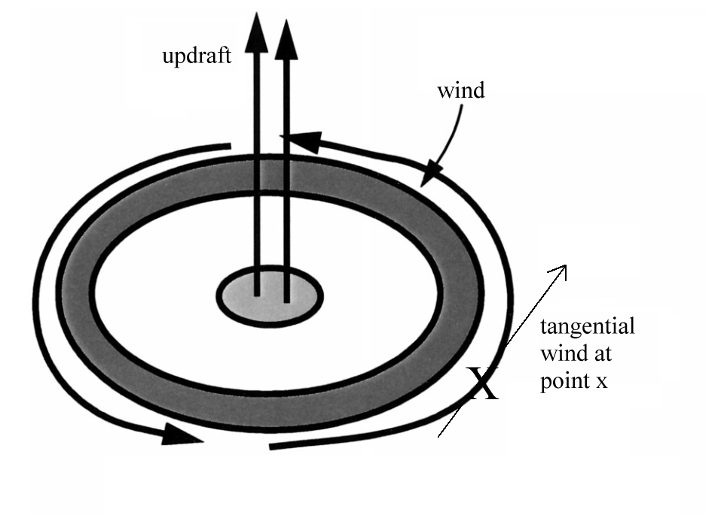
The model begins by assigning each point in a Cartesian grid x, y coordinates. These coordinates are then transformed to polar coordinates, where r is the distance from and theta is the angle from the origin to x, y:
$r=\sqrt{(x^{2}+ y^{2})}$ and $θ= \tan^{-1} y/x$
Any point can be represented in either cartesian coordinates (x,y) or polar coordinates (r, θ).
The tangential velocity V_{tan} can be calculated at each point using
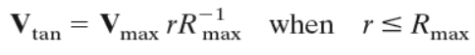
and
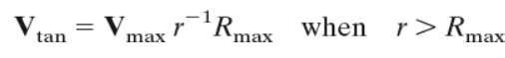
where V_{rmax} = the specified radial maximum wind velocity.
We can also calculate the lateral and vertical forces acting on a tree. The first force considered is the force of wind drag. The mean wind force F_{w} (Newtons) for each 1-m segment is given as:
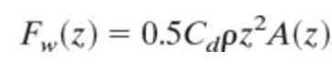
where C_{d} is the drag coefficient for the segment, ρ is the density of air, and A(z) is the projected cross-sectional area of the tree against the wind at height z.
To calculate the projected area of the crown against the wind, the model assumes a crown shape simulated as a series of triangles. For one type of tree called a loblolly pine, two triangles share a common base, with the vertex of one triangle extending upward and the other downward. The bases of the triangles are equal to 2 times the length of the longest branch in the crown. For loblolly pine, the upper triangle is taller than the lower to differentiate between the living and dead crowns.

As the wind speed increases, the canopy becomes streamlined. The reduction in crown area is 20% when the wind speed is less than or equal to 11 m/s and is 60% for wind speeds greater than 20 m/s. The streamlining factor S_{t} between these wind speeds is
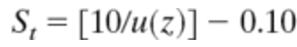

where u(z) is
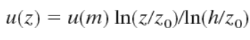.
where u(z) is the wind speed at height z, u(m) is the wind speed calculated at each grid point and is assumed to be located one tree height above the canopy, h is the tree height, and z₀ is the roughness length, taken to be 0.06 times the tree height.

Once the tree becomes streamlined and bent by the wind force, the force of gravity becomes important. This force is also calculated for each 1-m segment of the tree by
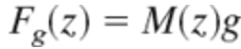

where g is the acceleration of gravity and M(z) is the green mass of the stem and crown.

16. Assume we are measuring a point where a specific tree is located, and we are using the center of a tornado as the origin (point (0,0)). The tree is located 18 meters in the x direction and 9 meters in the y direction. How far is the tree from the center of the tornado?

- 18 meters
- 20 meters
- 27 meters
- 37 meters
- 405 meters

17. If a tornado is measured to be ¼ mile wide, what is its radius in meters?

- 4 meters
- 201 meters
- 402 meters
- 1,320 meters
- 5,280 meters

18. Loblolly pine trees are usually planted with a density of 700-1,000 trees per acre. How many Loblolly pines would be expected within a 1 square-mile area if they were planted at maximum density?

- 448,000
- 640,000
- 4.48 million
- 6.4 million
- 640 million

19. If a tornado causes a path of destruction through this 1 square-mile area which destroys 0.6 acres of trees, which answer is the best estimate at the number of destroyed trees?

- 600 trees
- 270,000 trees
- 448,000 trees
- 1.2 million trees
- 3.8 million trees

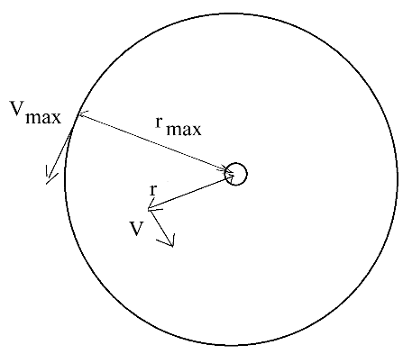
20. A tornado has a diameter as shown. If our tornado is 800 feet wide and has a Vmax tangential to the tornado of 55 m/s, what is the wind speed at a distance r=670 feet?

- 33 meters/sec
- 46 meters/sec
- 55 meters/sec
- 88 meters/sec
- 17,930 meters/sec

21. What is the force of wind drag on a tree at a height of 10m if radius of the tree is 1 meter. Assume the density of air is 1.2 kg/m³, and assume a drag coefficient of 0.55 for a pine tree.

- 1 N
- 10.3 N
- 33 N
- 104 N
- 207 N

By introducing the critical wind speed (Vc), which is the speed at which a tree falls (due to windthrow or stem break), the treefall pattern of a tornado can be generated. The tree falls in the direction of the wind blowing at the instant when V exceeds Vc.

For a pure vertical pullout loading condition, the upward movement of the tree is expected to be accompanied by a separation of a percentage of the outer root length from the surrounding soil. This separation can be attributed to frictional loss at the soil-root interface and the decrease in the number of roots involved in resisting the loads at the outer boundaries of the equivalent root-plate. Thus, the maximum pure pullout load (Pu) of the tree can be estimated using:

Pu = Wsh + Wrp + Qs

where Wsh is the shoot weight (stem + crown), Wrp is the root-plate weight and Qs is the pullout contribution of the exposed root length (i.e., which represents approximately 10% of the total pullout resistance).

The tree’s resistance to stem breakage assumes that the wind induced stress in the fibers of the tree stem is constant at all points between the canopy and the roots, as well as at the stem base. Thus, the applied stress, e.g., at chest height or at any other height can be calculated, and when it exceeds the MOR (Modulus of Rupture) for green timber, the stem will break. Therefore, the maximum bending moment (M_{sb}) that a tree stem can withstand without breakage can be calculated as:

$$M_{sb}= \frac{π}{32} ∙MOR ∙ {DBH}^{3} ∙ K_{not}$$

where M_{sb} is the critical bending moment for stem breakage, MOR is the modulus of rupture, DBH is the stem diameter at chest height and K_{not} is the knot factor to account for reductions in the capacity due to knots and other wood defects.

22. For two trees in the same forest, if the root-plate weight for tree B is double that of tree A, how much higher is the pullout load for tree B than for tree A?

- Half
- The same
- Double
- Four times
- Not enough information to tell

23. For a forest of otherwise identical trembling aspen, assume the trees have an MOR of 35 MPa and K_{not} values of 0.75. If one tree has a diameter of 10” and another tree has a diameter of 12”, how much higher is the larger tree’s value of M_{sb}?

- 10% higher
- 20% higher
- 72% higher
- 300% higher
- Not enough information to tell

24. What is the circumference of the trembling aspen with a 12-inch diameter?

- 0.07 meters
- 0.95 meters
- 1.9 meters
- 37.7 meters
- 75.4 meters

25. Suppose our forest is in the shape of a rectangle. From the origin, it extends 1.8 miles to the East and 2.1 miles to the North. Where is the farthest point in polar coordinates?

- (2.76 miles, 0.55 degrees)
- (4,441 miles, 49 degrees)
- (1.95 miles, 45 degrees)
- (2.76 miles, 49 degrees)
- (1.95 miles, 0.8 degrees)

