**Scenario: Building in Tropical Climates**

Your team of engineers is tasked with designing a sustainable home in the Caribbean focused on passive design strategies to maximize natural ventilation, lighting, and thermal comfort while minimizing energy usage. This home uses orientation, window placement, shading devices, and materials to achieve thermal efficiency and reduce the environmental impact.

1. If the optimal angle for a solar panel in the Caribbean is 15 degrees to maximize sunlight capture, and the roof angle is as shown, by how many degrees must the solar panel be adjusted to reach the optimal angle?

1. 5 degrees
2. 10 degrees
3. 15 degrees
4. 20 degrees
5. 25 degrees
6. This home is built so that the roof surface is perpendicular to the angle of the sun to maximize exposure for solar panels. The average angle of the sun is 65° when measured with respect to the ground. What should the angle of the roof be with respect to the ground?
7. 25°
8. 65°
9. 90°
10. 115°
11. 155°

The pitch of a roof is defined as the steepness of a roof, which is usually expressed as a ratio of the roof's vertical rise to its horizontal span. For example, a roof with a pitch of 4:12 means that the roof rises 4 inches for every 12 inches of horizontal run.

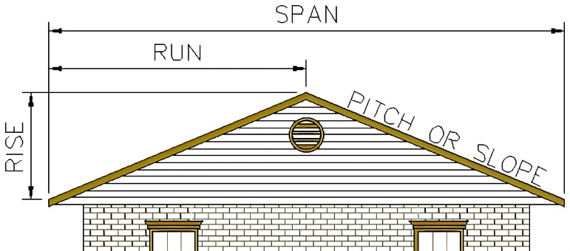

1. Find the pitch of a roof with a rise of 61 inches and a span of 21.76 feet.
2. 1.4:12
3. 5.6:12
4. 61:13.9
5. 61:21.8
6. 61:260
7. A diagram of a house and a yellow light

   Description automatically generatedA home is built on a hillside with an angle of 12°. The angle of the sun with respect to the ground is 72°. The home is to be perfectly level, with a roof perpendicular to the sun as it hits the roof. If the rise of the roof is 1 meter, what is the pitch of the roof?
8. 0.85:1.0
9. 6.93:12
10. 10.4:12
11. 61:13.9
12. Not enough information to answer

5. A room has three skylights in the roof each measuring 1 meter by 1.5 meters. If the glass transmits 70% of natural light, what is the equivalent area of natural light transmitted into the room through the windows?

1. 1.05 m2
2. 1.5 m2
3. 2.14 m2
4. 3.15 m2
5. 4.50 m2

6. The insulation of a home is being improved by adding a filter which will filter the light through one skylight. This layer will transmit 70% of the natural light which comes through one of the skylights. What is the total equivalent area of natural light transmitted into the room through the windows?

1. 0.74 m2
2. 1.05 m2
3. 2.21 m2
4. 2.84 m2
5. 3.15 m2

The U-value, also known as thermal transmittance or thermal conductivity, measures the amount of heat transferred through a material or an assembly of materials, such as a window. It is expressed in watts per square meter per degree Celsius (W/m²K). The lower the U-value, the better the insulation and energy efficiency of a building component. U-values are crucial in construction because they help evaluate the thermal performance of walls, roofs, floors, windows, and doors. Windows may be specified by Ug which is the U-value for the glass only, or Uw, the U-value for the whole window, including the glass and frame. Sometimes, the insulation value is specified as the R-value, which is the capacity of an insulating material to resist heat flow. The higher the R-value, the greater the insulating power. The R-value is the reciprocal of the U-value. R is also defined as

In this case, the total U-value is:

where

Ap is the area of the glass pane,   
Uf is the U-value of the frame,  
Af is the area of the frame,   
lg is the length of the line around the pane and inside the frame, and  
Ψg is thermal bridging coefficient of the joining material from the frame to the pane of glass.

When finding the U-value of walls, roofs, etc., we add up the U-value of each layer to find the overall U-value, assuming the material is homogeneous.

Old single-pane windows can have U-values of around 5.8 W/m2K, and older double-pane windows can be around 2.8.  U-values are now much lower, and typically a good U-value for modern windows is below 1.6 W/m2K.

7. A window is installed as shown, where the size of the windowpane is 47.25” wide, 55.12” tall, with a frame 3.94” wide surrounding the pane of glass. We are given Ug = 0.70 W/m2K, Uf = 0.70 W/m2K and the thermal bridging coefficient of the material attaching the frame to the window = 0.030 W/mK. Find the U-value of this window.

1. 0.24 W/m2K
2. 0.70 W/m2K
3. 0.77 W/m2K
4. 0.84 W/m2K
5. 1.29 W/m2K

8. If we cut the width of the frame in half, what happens to the overall U-value?

1. Significantly increases
2. Remains about the same
3. Decreases by half
4. Significantly decreases (by more than half)
5. Not enough information to tell

9. The walls of a home, which were a single layer of bricks, are replaced with a multi-layer, insulated wall. Suppose we use three layers of insulation material: 12 cm of an outer and inner layer with a thermal conductivity value of 0.60 W/m2K, and 16 cm of a middle layer with a thermal conductivity value of 0.04 W/m2K. Also assume the outer face of the insulated layer adds an additional 0.04 m2K/W, and the inner face adds 0.13 m2k/W. What is the resulting R-value of the layers of material?

1. R = 0.218 m2K/W
2. R = 0.228 m2K/W
3. R = 1.03 m2K/W
4. R = 1.41 m2K/W
5. R = 4.57 m2K/W

10. Considering the high temperatures, a special reflective wall paint reduces solar heat gain by 80% for the first 200W, by 50% for 200W to 600W, 40% from 600W to 1200W and 20% above 1200W. If a wall without the paint would normally absorb 1000 watts of solar energy, how much energy does the wall absorb after applying the paint?

1. 400 watts
2. 480 watts
3. 520 watts
4. 600 watts
5. 1000 watts

11. Assume a house is as shown (looking up, from under the house at the floor). Assuming a very simplified model where all airflow into the house displaces air already in the house, how many minutes will it take to replace all the air in this house if the house has 3 cubic ft/second blows in through open windows?

1. 141 minutes
2. 144 minutes
3. 145 minutes
4. 149 minutes
5. Not enough information to determine

12. To maximize cooling, floor tiles are made of a material that has a high thermal mass, absorbing heat during the day and releasing it at night. If the floor area is 100 square meters and the tiles absorb 50 watts per square meter per hour during 10 hours of daylight, how much total heat is absorbed by the floor tiles in one day?

1. 500 watts
2. 5,000 watts
3. 50,000 watts
4. 500,000 watts
5. 5,000,000 watts

13. An engineer is assessing the dynamic response of a Caribbean home's structure to wind-induced vibrations. The building is modeled as a cantilever beam with a natural frequency that needs to be calculated for safety analysis. If the building acts like a uniform beam with a length (L) of 30 meters, a mass per unit length (*µ*) of 250 kg/m, and a flexural rigidity (El) of 2.5 x 107 Nm². The formula for the fundamental natural frequency of a cantilever beam:

What is the natural frequency in Hz?

1. 0.5 Hz
2. 0.4 Hz
3. 0.3 Hz
4. 0.2 Hz
5. 0.1 Hz

A team of environmental engineers are tasked with designing a sustainable Caribbean home that minimizes the urban heat island effect, which can exacerbate local temperatures in densely built areas. The design involves incorporating green roofs, using high-albedo (reflective) materials, maximizing vegetation, and installing energy-efficient systems. The home aims to reduce heat absorption and improve local air quality while ensuring it remains cool and comfortable without excessive energy consumption.

14. A green roof can retain 40 liters of water per square meter. If the green roof covers an area of 200 square meters, how much water in total can it retain?

1. 6,000 liters
2. 7,000 liters
3. 8,000 liters
4. 9,000 liters
5. 10,000 liters

15. An engineer is calculating the optimal size for rainwater cisterns to support irrigation during dry periods. If the average rainfall in the area is 800 mm per year and the catchment area of the roof is 250 square meters, calculate the total volume of rainwater that can be collected in a year. Assuming a 90% collection efficiency, how much water in cubic meters will actually be collected?

1. 250 m³
2. 225 m³
3. 200 m³
4. 220 m³
5. 180 m³